

Name: S B Sabesh Course Code: ITA0330
Reg No: 192472153 Course Name: Mobile Computing

Experiment 1: Basic Cellular System Diagram in Figma

Aim: To create a diagram illustrating the components of a basic cellular system using Figma.

Procedure:
- Open Figma and create a new design file.
- Create a frame with a light-gray background.
- Draw five rectangular boxes and arrange them vertically.
- Add the names: Mobile Device, BTS, BSC, MSC, and External Networks.
- Give each box a different color.
- Connect the boxes using arrows to show communication.
- Add short descriptions inside each box.
Output:
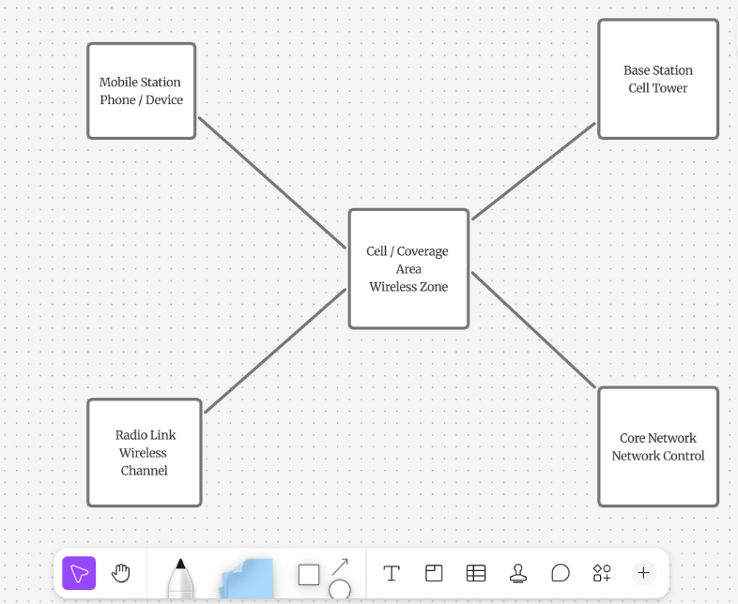

Result: A basic cellular system diagram was created successfully using Figma.

Experiment 2: Mobile Station UI Design Using Figma
Aim
To design a user interface prototype for a mobile station using Figma, focusing on connectivity and convenience features such as Wi-Fi, mobile data, Bluetooth, calls, messages, and network settings.
Procedure
- Open Figma and create a new design file.
- Create a smartphone frame using a suitable mobile device preset.
- Design the home screen with network status, signal strength, and battery level.
- Add buttons for Wi-Fi, mobile data, Bluetooth, and airplane mode.
- Add shortcuts for calls, messages, contacts, and settings.
- Use suitable colors, icons, and rounded buttons to make the interface user-friendly.
- Open the Prototype tab and connect the buttons to different screens or interactive states.
- Test the prototype using Present mode to verify the interactions.

Output:
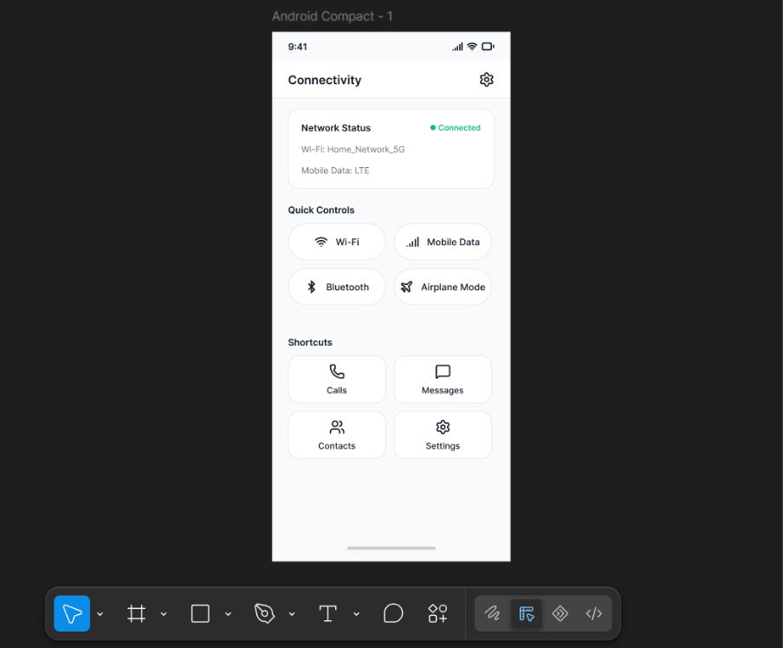

Result: A basic cellular system diagram was created successfully using Figma.

3.Experiment: Network Switching Subsystem Flowchart Using Figma

Aim: To develop a flowchart in Figma illustrating the operation of the Network Switching Subsystem (NSS) in a mobile cellular system.

Procedure:
- Open Figma and create a new design file.
- Use oval shapes for Start and End.
- Use rectangles for processing steps and diamonds for decisions.
- Connect all shapes using arrows.
- Add Yes and No labels to the decision branches.
- Apply suitable colors and align the shapes neatly.
- Test the flowchart and save the design.

Output:

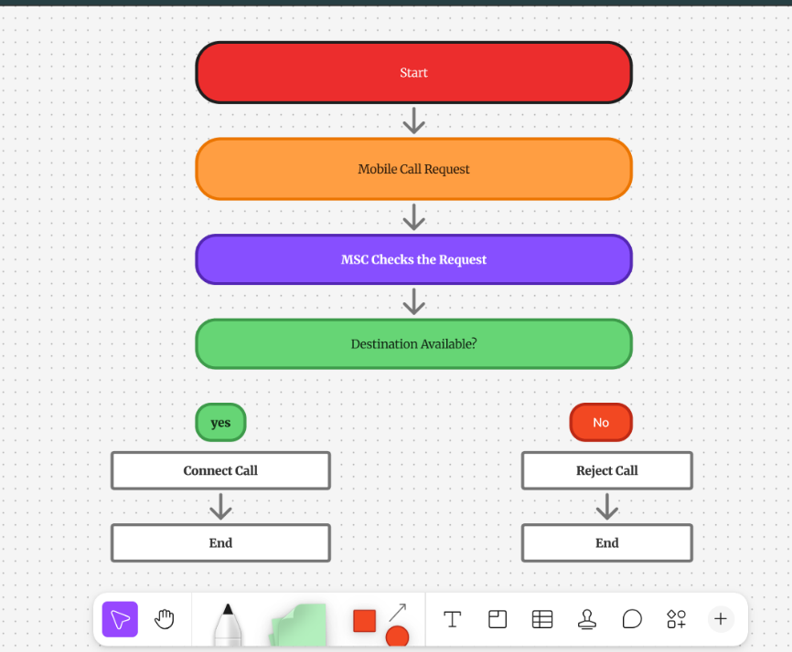

Result: A flowchart illustrating the operation of the Network Switching Subsystem in a mobile cellular system was created.

4 Experiment Name: Mobile Network Protocol Stack Visualization Using Figma
Aim:
To create a visual representation in Figma highlighting the key layers and functions of mobile network protocol stacks.

Procedure
- Open Figma and create a new FigJam board.
- Draw five rectangles and arrange them vertically.
- Label the rectangles as Application Layer, Transport Layer, Network Layer, Data Link Layer, and Physical Layer.
- Add the main functions of each layer below its name.
- Use different colors to distinguish the layers.
- Connect the rectangles using arrows to show the communication flow.
- Align the shapes neatly and save the design.
Output:
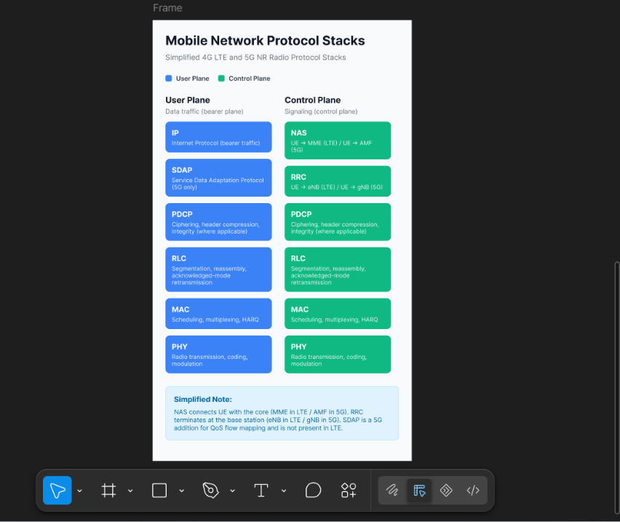

Result:
A visual representation of mobile network protocol stacks was created in Figma, showing the five layers and their main functions in mobile communication.

5 Experiment Name:Mobile Application Wireframe Design Using Figma
Aim
To design a wireframe for a mobile application using Figma that incorporates localization features such as language selection, regional settings, and location-based services.
Procedure
- Open Figma and create a new Design file.
- Select a mobile phone frame.
- Design a home screen with a title, menu, and navigation buttons.
- Add a language selection option with choices such as English, Hindi, and Tamil.
- Add location-based features such as current location, map, and nearby places.
- Include regional settings such as date format, time format, and currency.
- Use simple rectangles, text, and icons to create the wireframe.
- Use the Prototype tab to connect the screens and test navigation.
- Save the design.
Output:
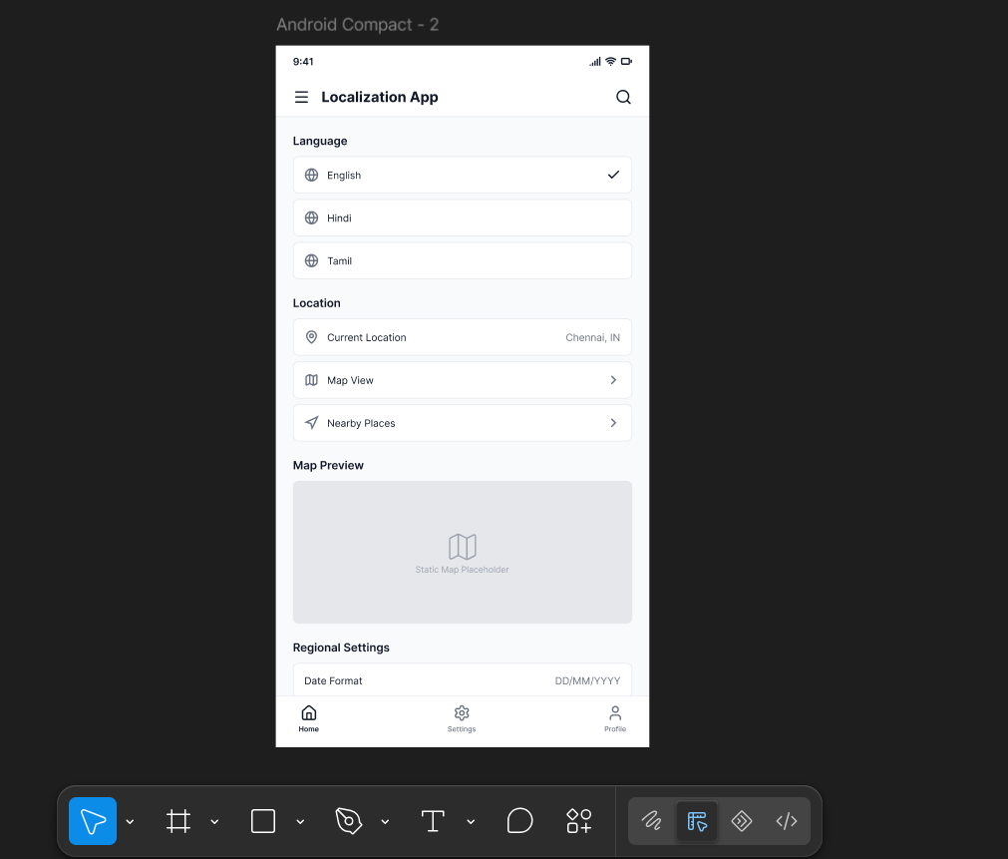

Result:
A mobile application wireframe was designed in Figma with localization features, including language selection, regional settings, and location-based services.

Link: https://www.figma.com/design/w4E1AZxh5zW76OC0oLS0kk/Untitled?node-id=0-1&p=f&t=IWNqw5Fr4QRvSRDu-0

Link: https://www.figma.com/board/I6rKGZCGbWvS1XafdcFIFo/Untitled?t=IWNqw5Fr4QRvSRDu-0

